Research & Insights Analyst – Take Home Task

**Task 1**

You have been provided with 3 datasets containing traffic and audience figures for news.com.au.:

* news.com.au Verticals by Month and Device
* news.com.au Verticals by Referrer and Device
* news.com.au Verticals by Time of Day and Device

Your task is to perform the below mentioned ETL activities:

1. Using R or Python, create a consolidated database for each of the shared excel files. The schema for each of the databases should be in the given format:

For NCA_Verticals_by_Time_of_Day_Device.xlsx:

| Brand | Hour_of_day | Page Views | Unique Visitors | Device Type |
| --- | --- | --- | --- | --- |
| news.com.au - Entertainment | 00:00 | 3,155,302 | 1,481,701 | Total |
| news.com.au - Entertainment | 00:00 | 890,988 | 431,570 | Desktop/Tablet |
| news.com.au - Entertainment | 00:00 | 2,263,128 | 1,050,260 | Mobile |

For NCA_Verticals_by_Month_Device.xlsx:

| Brand | Month | Page Views | Unique Visitors | Device Type |
| --- | --- | --- | --- | --- |
| news.com.au - Entertainment | Jan 2019 | 249,660,297 | 14,283,716 | Total |
| news.com.au - Entertainment | Jan 2019 | 105,802,096 | 5,681,040 | Desktop/Tablet |
| news.com.au - Entertainment | Jan 2019 | 143,788,345 | 8,606,749 | Mobile |

For NCA_Verticals_by_Referrer_Device.xlsx:

| Brand | Referrer Type | Referrer Instances | Device Type |
| --- | --- | --- | --- |
| news.com.au - Entertainment | Search Engines | 11,500,543 | Total |
| news.com.au - Entertainment | Search Engines | 7,725,495 | Desktop/Tablet |
| news.com.au - Entertainment | Search Engines | 3,763,123 | Mobile |

1. Using R or Python libraries, visualise the monthly trend for Page Views and Unique Sessions for each of the brands from the consolidated database for NCA_Verticals_by_Month_Device.xlsx.
2. Using SQL, answer the following questions:
   1. Top 3 brands with maximum number of Mobile Referrer Instances for Search Engines.
   2. Total number of page views generated by news.com.au- Finance between 4am and 6am.
   3. Total number of Desktop/Tablet page views generated by all the brands between August 2019 to October 2019.

Put together the scripts with its output along with any other steps taken by you to clean and restructure the data. We are interested in not only your output, but your approach to each task.

**Task 2**

There is talk of creating a Chinese language version of news.com.au. What steps would you take to find out whether or not this would be a reasonable proposition? Please outline your method/approach, what tools you would use, and anything else that you would do to come up with a recommendation.

Feel free to offer any other thoughts or recommendations you have based on all the information provided.

**Task 3 - Adobe Analytics specific questions**

1. What is the primary function of an eVar?
2. What are the Analytics variables you use to find pathing behaviour?
3. What is a list prop and how is it used?
4. Explain the major difference between participation and allocation
5. Explain the containers in segments and how they can impact your reports
6. How would you build a sequential segment? When might you use this?
7. In Workspace which areas can you use a segment?
8. What is the meaning of “other” in mobile devices report?
9. GIve an example of an Alert you would set in analytics
10. In Workspace what are some of the UI limitations you might experience when building and exporting reports? And how would you mitigate these?
11. Based on the screengrab below, tell me the following:

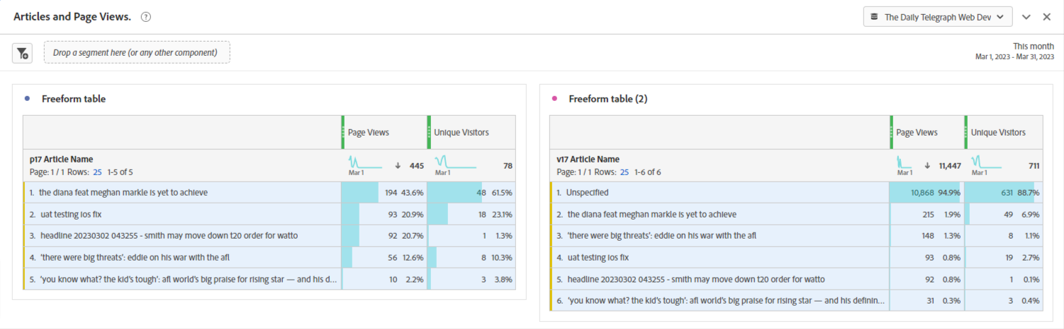

* 1. What does unspecified mean?
  2. Why are the pageviews different in each report for the same article?

1. Give an example of when you have created a calculated metric and what you used it for. What limitations are there with calculated metrics?
2. What is a Virtual Report Suite and when would you use it?
3. How can you quickly build a segment or a visualisation from a freeform table?